Open the Registry Editor by hitting Start and then typing “regedit.” Press Enter to open Registry Editor and give it permission to make changes to your PC.

[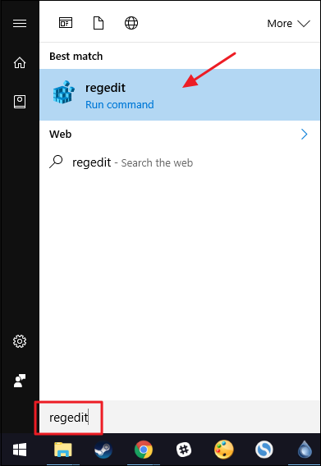](https://www.howtogeek.com/wp-content/uploads/2016/11/own_1.png)

In the Registry Editor, use the left sidebar to navigate to the following key:

HKEY_CLASSES_ROOT\Directory\shell

[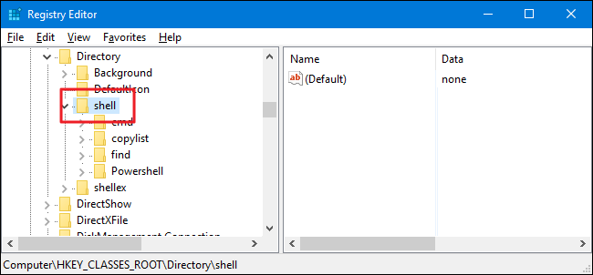](https://www.howtogeek.com/wp-content/uploads/2017/01/apc_2.png)

Next, you’ll create a new key inside the shell key. Right-click the shell key and choose New > Key. Name the new key “powershellmenu.” We’re naming our new key powershellmenu because in Windows 8 and 10 (and as you can see in our screenshot), a Powershell key already exists that serves other functions.

[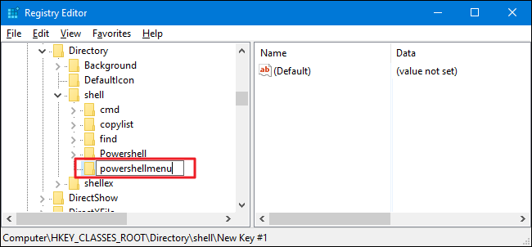](https://www.howtogeek.com/wp-content/uploads/2017/01/apc_3.png)

Now, you’ll change the (Default) value inside the new powershellmenu key. With the powershellmenu key selected, double-click the (Default) value to open its properties window.

[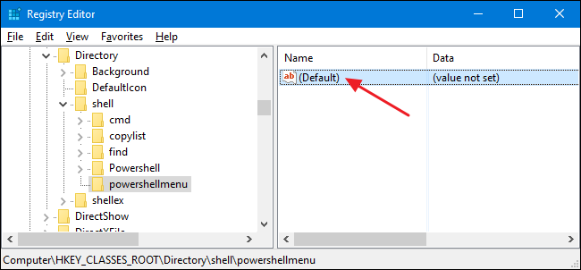](https://www.howtogeek.com/wp-content/uploads/2017/01/apc_4.png)

In the properties window, set the value in the “Value data” box to “Open PowerShell Here” and then click “OK.” This gives the command the name that will appear on the context menu.

[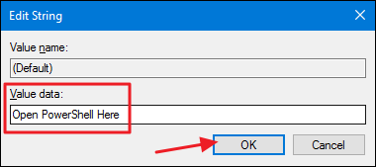](https://www.howtogeek.com/wp-content/uploads/2017/01/apc_5.png)

Optionally, you can also set the command so that it only appears if you hold Shift down while right-clicking a drive—much the same way that the “Open Command Prompt” command is hidden unless you Shift+right-click a folder. To to that, right-click the powershellmenu key and choose New > String Value. Name the new value “Extended.” You don’t need to make any changes to it. Just having that string there will cause the command to be hidden behind Shift key access.

[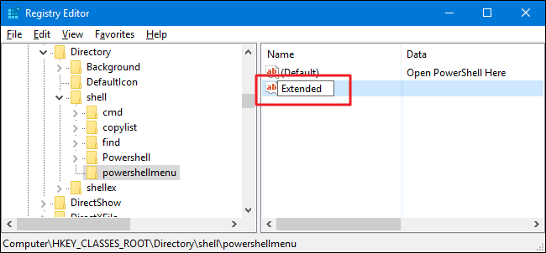](https://www.howtogeek.com/wp-content/uploads/2017/01/apc_6.png)

Whether you took the optional step of creating the Extended value or not, the rest of the process is the same. You’ll next need to create a new key inside your powershellmenu key. Right-click the powershellmenu key and choose New > Key. Name the new key “command.”

[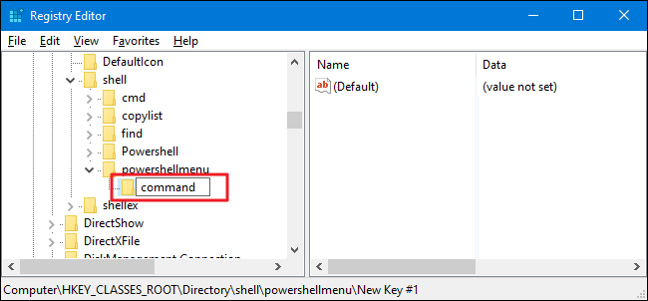](https://www.howtogeek.com/wp-content/uploads/2017/01/apc_7.png)

Now, you’ll change the  (Default) value inside the new command key. With the command key selected, double-click the (Default) value to open its properties window.

[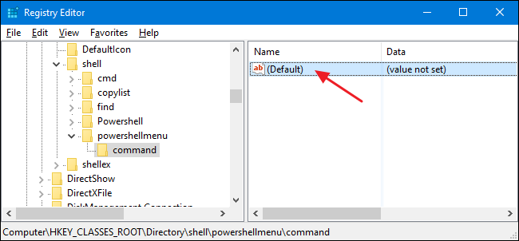](https://www.howtogeek.com/wp-content/uploads/2017/01/apc_8.png)

The (Default) value specifies the actual command that will run when you select the option on the context menu. Type the following text into the “Value data” box and then click “OK.”

C:\\Windows\\system32\\WindowsPowerShell\\v1.0\\powershell.exe -NoExit -Command Set-Location -LiteralPath '%L'

[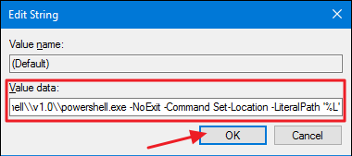](https://www.howtogeek.com/wp-content/uploads/2017/01/apc_9.png)

The changes should take place immediately, so you can exit out of Registry Editor. To test it out, just right-click (or Shift+right-click if you set up that option) any folder and make choose the ”Open with PowerShell” command.

[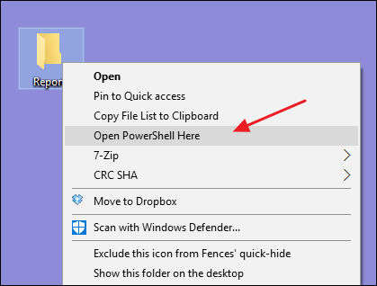](https://www.howtogeek.com/wp-content/uploads/2017/01/apc_a.png)

The PowerShell window should open immediately and, after a few moments, place you inside the folder you right-clicked.

[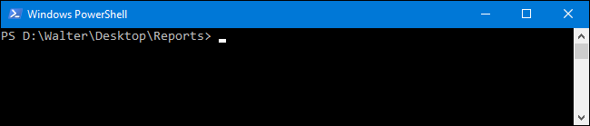](https://www.howtogeek.com/wp-content/uploads/2017/01/apc_10.png)

If you want to reverse the changes at any time, just go back into the Registry and delete the powershellmenu key that you created. This will automatically delete any values and other keys you created inside the powershellmenu key and remove the command from your context menu.

**Download Our One-Click Registry Hacks**

[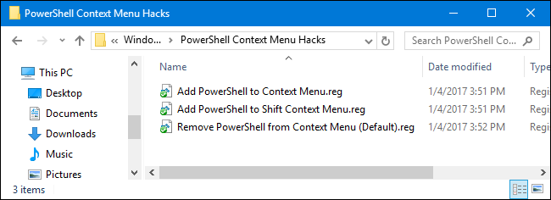](https://www.howtogeek.com/wp-content/uploads/2017/01/apc_11.png)

If you don’t feel like diving into the Registry yourself, we’ve created some registry hacks you can use. The “Add PowerShell to Context Menu” hack adds the PowerShell command to the regular context menu. The “Add PowerShell to Shift Context Menu” adds the PowerShell command to the context menu you get when you use Shift+right-click. And the “Remove PowerShell from Context Menu” removes the command no matter which way you added it. All three hacks are included in the following ZIP file. Double-click the one you want to use and click through the prompts.